FACULTY EVALUATION
Programme Name: SBVP ALUMNI MASTERCLASS - SCALE Module I Online Kenya (20th April 2026 - 24th April 2026)
Session: Customers and competitor evaluation || Market potential evaluation || Customers, competitors and market planning
Faculty Name: Lenah Gachoki
No. of Respondents: 17
No. of Participants: 17
Evaluation Parameter | (%) Individual Score | (%) Programme Average
Punctuality (Commencement and Completion of Sessions) | 96 | 96
How well do you understand the core concepts presented? | 89 | 90
Rate your confidence in applying the new skills learnt | 85 | 84
Degree of Faculty preparedness for the sessions | 93 | 94
Content and methodology of the program | 94 | 93
Quality of class and group discussions | 92 | 90
The information presented in the course is relevant to my work (ministry) | 92 | 93
Average scores | 92 | 91

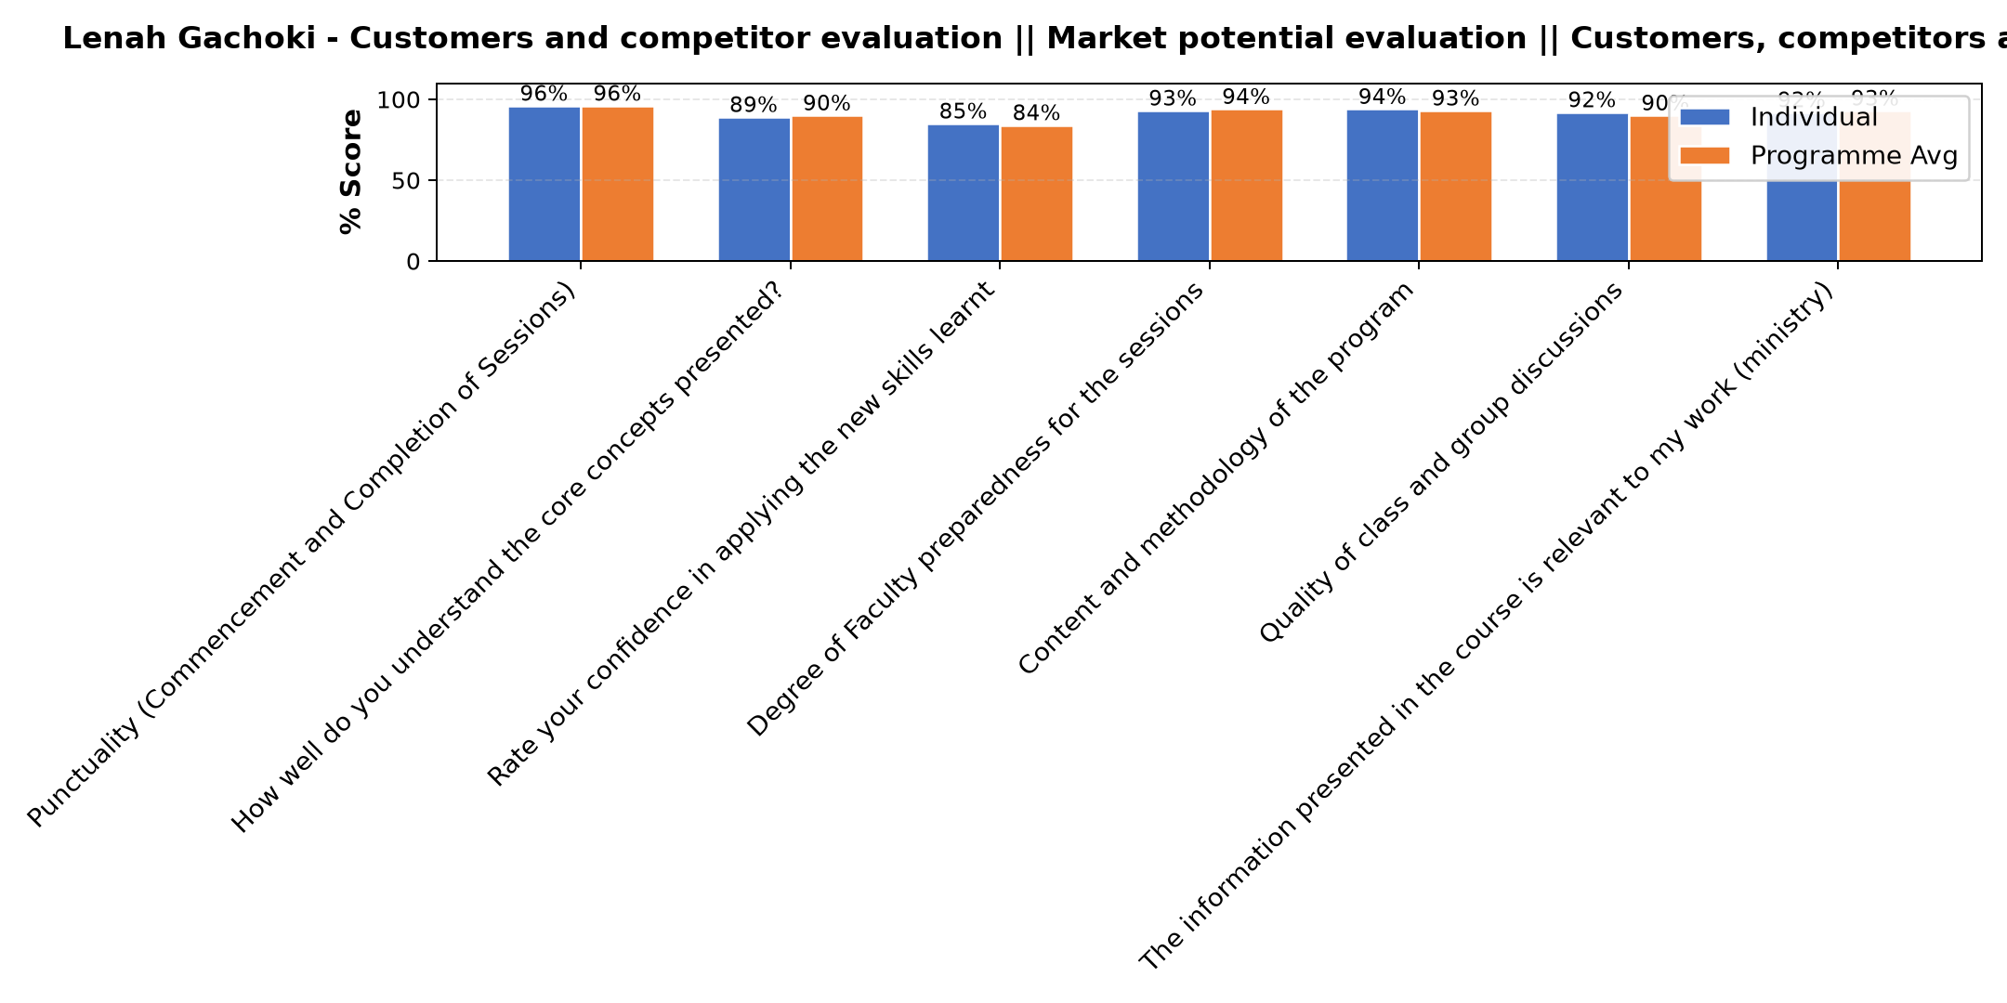

Comments & Feedback
- • Not that I know of
- • Resistance to change, lack of structure and support
- • It needs a lot of keeness, and time, growth is gradual, it's not one day thing
- • So far no barriers. We will try our best
- • Perception of the people
- • The barrier might be if am unble to identify my dominant color and work on it in order to balance with the others.
- • Finance
- • Personal challenges
- • I have to be aware of who I am inorder to help others however it will take time for them to understand how and why I do what I do but I believe with time we will be able to have a common understanding
- • Lack of courage
- • Lack of confidence
- • Well done
- • Luck of resources .Luck of proper technology and financial support.
SUBMITTED THROUGH:
SBS Evaluation Automation System

